**Leader Overview**



**Volume Overview**

**Stand Firm**

*The world thinks of power as action. Powerful people are able to take control, able to change things. But Jesus blessed the meek, the hungry, and the poor. There is a power this world overlooks. There is power in standing firm in faith. Christians have long stood their ground, not to gain this world’s power but as witnesses to a better world to come. So we stand strong, committed, and bear witness to the world.*

**Session Overview**

**Be Committed**

*In this* **Live** *session, kids will discover the importance of being committed to serving God. Even though it won’t always be easy, we’re called to serve God no matter what we face. From the example of Stephen, kids will learn how to follow God even in the face of persecution.*

**Bible Lesson**

Stephen Is Persecuted for His Faith

[Acts 6:2–15](https://ref.ly/logosref/Bible.Ac6.2-15); [7:51–60](https://ref.ly/logosref/Bible.Ac7.51-60)

**Faith Fact**

I will serve God no matter what.

**Faith Verse**

[Ephesians 6:13](https://ref.ly/logosref/Bible.Eph6.13) (NLT)

Put on every piece of God’s armor so you will be able to resist the enemy in the time of evil. Then after the battle you will still be standing firm.

**Preparing for the Session**

**Leader Preparation Time: 20–25 Minutes**

|  |
| --- |
| ***You Will Need***  ***Large Group***   * *Bible* * *Worship songs (Song suggestions: “Won’t Stop Now” by Elevation Worship; “Surrounded (Fight My Battles) Lyric Video” by Bethel Music; “Battle Belongs” Lyric Video by Phil Wickham)* * *For groups not using a phone or tablet only, add:*   *• Projector or TV*  *• Laptop*  *•* ***Countdown30 Video****–30 seconds*  *•* ***Faith Fact Slide***  ***• Faith Verse Video or Slide***  ***• Bible Lesson Video***  *•* ***Teaching Point Slides 1–3***  *•* ***Teaching Time Slides A and B***   * *Broom* * *Dish* * *Dish towel* * *Baby bottle* * ***Large Group Response Page****, one per every four kids* * *Pencils, one per kid* * *Scissors*   ***Small Group***   * ***Small Group Group Connection Page****, one per group* * *Plastic cups, one per group* * *Scissors* * *Soft ball, one per group* * *Bibles for kids in the group to share* * *Bible, one per group* * ***Small Group Activity Page****, one per kid* * *Pencils, one per kid*   *To access session content and videos from a computer, visit:* [*BibleEngagementProject.com/downloads*](https://bibleengagementproject.com/downloads) |
| ***Getting Ready***  ***Large Group***   * *Download videos and slides if needed.* * *Select worship song(s) and have them ready to play.* * *Read the Bible Lesson Scripture to prepare for Teaching Time.* * *Print copies of the* ***Large Group Response******Page****, one per every four kids.* * *Cut apart the pages into four segments each.*   ***Small Group***   * *Print the* ***Small Group Group Connection Page****, one copy per group.* * *Cut apart the slips and fold them so the kids can’t read the slips.* * *Place a set of slips in the cup.* * *Print copies of the* ***Small Group Activity Page,*** *one per kid.*   *First time leading Live for* Kids*? Check out the* [*Facilitator Guide*](https://0b769b0ed3569ef9d18b-f88d8272f61086866d50d048b43ef630.ssl.cf2.rackcdn.com/sites/biblengagementproject/Listen_Facilitator_Guide.pdf)*.* |

**Large Group**

**30 Minutes**

*See what’s needed at the beginning of the session.*

**Introduction**

How is everyone today? *(Group response)* I’m so glad you joined me today. Time for everyone to stand up. *(Group response)* Now, stomp with each foot one time and then plant your feet firmly on the floor. *(Group response)*

• *Each time you say, “Stand firm,” stomp with each foot to emphasize the words. Have kids follow you.*

Great! For our next few times together, we’ll learn how to stand firm *(stomping action)* in our faith in God. Do you think we should always follow Him? *(Group response)* Definitely! Do you think it’s always easy to stand firm *(stomping action)* and follow Him? *(Group response)* Definitely not! That’s why it’s so important for us to learn how to stand firm *(stomping action)* in our faith no matter what we face. Have a seat.

• *Have kids sit back down.*

Today, we’ll focus on what it looks like to be committed to serving God. What are a few ways that people serve God? *(Allow responses.)* Those are some great ideas. *(Show the Bible.)* Serving God requires us to be committed to Him no matter what—even in the face of difficulty.

• *Insert a personal story about how you remained committed to God when no one else around you seemed to be following Him. Try to keep it light and something kids can relate to if possible.*

• *If you can’t think of a personal story immediately, tell a story about someone else who stood firm in their commitment to God. For example, a group of kids was teasing another kid at recess. Another kid who was watching stood up and told the group to stop teasing the first kid.*

During the Bible story, we’ll learn about a man named Stephen who stayed committed to serving God even though he faced death.

**Faith Fact**

When it’s hard or it seems no one else is doing it, we’re called to serve God. As a reminder, our Faith Fact today is **I will serve God no matter what**.

• *Show the* ***Faith Fact Slide.***

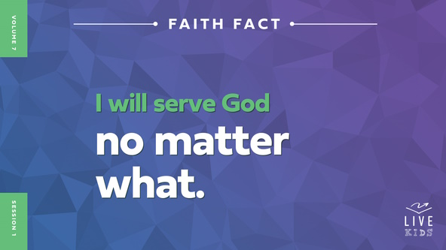

The great news is that God is always with us even when everything else seems to be working against us. That’s why it’s so important to remain committed to serving God even if life seems to be spinning out of control. Let’s stand up and say the Faith Fact together while we spin around in a circle. **I will serve God no matter what.** Let’s do it one more time. **I will serve God no matter what.** Great job! Have a seat again.

**Game**

**Stand Firm**

|  |
| --- |
| ***You Will Need***   * ***Countdown30 Video****–30 seconds*   *No prep needed for this activity.* |

We’re talking about the importance of being committed and standing firm in our faith in God even when we face challenges. Let’s see how well you can stand firm in today’s game. Standing on two feet is pretty easy. What about standing on only one foot, what about hopping up and down, or what about running in place? Do you have what it takes to stand firm when you face extra challenges? *(Group response)* We will see!

I’ll call out an action you need to do every 30 seconds. If you stop doing the action before time is up, you’ll need to sit down. Then, you can rejoin us for the next action. Let’s see who can do the best job of standing firm.

• *Play the* ***Countdown30 Video*** *and call out an action from the list below.*



• *Have kids take a seat if they fail to do the action for 30 seconds.*

• *Determine the winner(s). Then play another round.*

• *Jog in place.*

• *Stand on one foot.*

• *Stand on the other foot.*

• *Stomp with both feet.*

• *Hop on one foot.*

• *Stop and stand perfectly still.*

Way to stand firm! Those challenges were hard, but it can be a lot harder to stand firm and remain committed to serving God when we face challenges in life. Serving God isn’t always the easiest choice, but it is always the right one.

**Worship**

There are many ways to show God that we’re committed to serving Him. one way is through worship, which is showing God we love Him and want to spend time with Him. Let’s worship God right now through singing.

• *Lead the kids in singing one or two praise songs. See suggestions at the beginning of the session.*

**Bible Lesson**

Thanks for serving God through your worship. God loves it when we spend time worshipping Him and spend time in the Bible, His Word. Let’s look at what it means to be committed to serving God in all parts of our life. First, let’s pray.

**Prayer**

|  |
| --- |
| *Dear God, we are so thankful for the opportunity to serve You. Help us to remain committed to You no matter what we face. Amen.* |

**Video Intro**

Just before we look at the Bible story, let’s watch this video.

• *Play* ***Bible Lesson Video****.*

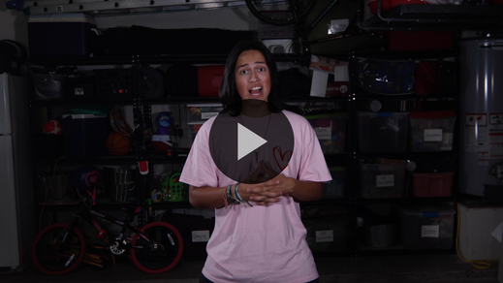

**Bible Story**

**Stephen Is Persecuted for His Faith**

That video was a great lead-in to our Bible story today. Before we hear the Bible story, it’s important to know that it doesn’t end like we might want it to. This true story about Stephen teaches us that we must remain committed to God even when that means we don’t get a typical happy ending like most movies have. But, when we choose to follow God and stay committed to Him, we’ll receive the best happy ending because we’ll get to spend eternity with Him. The world has nothing to offer us that even comes close to spending forever with God. It is worth anything!

**Teaching Time**

|  |
| --- |
| ***You Will Need***   * *Broom* * *Dish* * *Dish towel* * *Baby bottle*   *No prep needed for this activity.* |

Stephen is a great Bible example of someone who was willing to remain committed to God no matter what. Stephen knew that being committed to Jesus was more important than anything in this world. He kept his focus on Jesus in a very difficult and scary situation. Stephen wasn’t strong or brave enough on his own. The Holy Spirit gave him the courage and strength to stand firm.

Let’s read about how Stephen was chosen to serve. Grab your Bible or pull up a Bible app on your device. Turn to [Acts 6](https://ref.ly/logosref/Bible.Ac6) to begin.

• *In order to keep Large Group time moving along, we recommend that the leader reads the Scripture portions aloud (*[*Acts 6:2–15*](https://ref.ly/logosref/Bible.Ac6.2-15)*;* [*7:51–60*](https://ref.ly/logosref/Bible.Ac7.51-60)*).*

• *Optional: Remind the kids to mark this place with their Bible bookmark so they can read it on their own at home.*

**1. Stephen was chosen to serve God and His people.**

• *Show the* ***Teaching Point 1 Slide.***

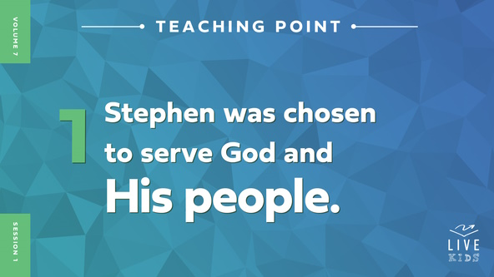

• *Read* [*Acts 6:2–8*](https://ref.ly/logosref/Bible.Ac6.2-8)*.*

As the Church grew, Jesus’ first disciples, called *apostles* in these verses, became very busy trying to lead the Church. So much activity seemed to keep them from having enough time to do the very important job of teaching the Bible. They decided they needed help.

That’s why Stephen and six other men were chosen to run the food program. Their job was to make sure food was handed out fairly to those who needed it. one of the main groups of people who needed food were widows. Widows are women in the Church whose husbands had died. Jesus taught that the Church needed to help take care of them. Does that sound like an important job to you? *(Group response)* Almost anyone could give out food. Stephen clearly showed that he was committed to serving God with excellence even in a less important role.

• *Invite three kids to the front to help you. Give them the broom, dish and dish towel, and baby bottle.*

Let’s see if our volunteers can tell us how to serve God with what I’ve given them. *(Allow responses.)* Good job! You can sit down again. What are some other things people might do to serve God? *(Allow responses.)* Remember, we can serve God in many ways. In fact, anything we do with the right attitude and motives can be a part of serving God. Like Stephen served God by giving others food, we can serve God when we help others in small and big ways, too.

In verse [8](https://ref.ly/logosref/Bible.Ac6.8), we learned that Stephen ended up serving God in more and bigger ways than just handing out food to people. How did God use him? *(Group response)* Stephen didn’t do those miracles on his own. Verse [3](https://ref.ly/logosref/Bible.Ac6.3) says that he was a man full of faith and the Holy Spirit. Stephen made sure that he was filled with all the right things. That prepared him for the extremely hard test he would face.

**2. Stephen was personally attacked for serving God.**

• *Show the* ***Teaching Point 2 Slide.***

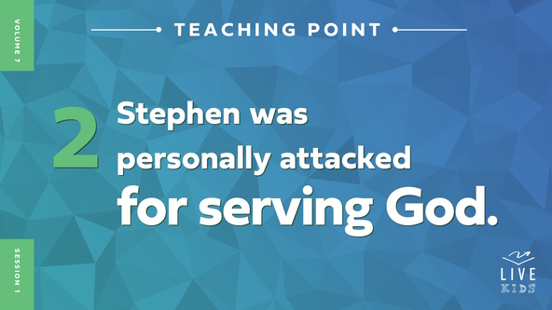

• *Read* [*Acts 6:9–15*](https://ref.ly/logosref/Bible.Ac6.9-15)*.*

Wow! Here Stephen was doing good things like serving food to those who needed it and being used by God to do miracles. Does it surprise you that he had enemies? *(Group response)* Even though Stephen was devoted to serving God, there were some people who didn’t like the things he was doing. What did they do about it? *(Allow responses.)*

First, they tried arguing with him. Did that work? *(Group response)* No! Next, they had people lie about Stephen. Can you imagine having someone make up lies about you? Maybe you can. Raise your hand if someone has ever made up a lie about you or told someone else something unkind about you. *(Group response.)* It hurts! I’m so sorry that you had to deal with that.

As hard as it was to be lied about, Stephen’s situation only got worse. The lies they spread about him were so bad that he ended up being arrested. And after all of this, did Stephen look afraid? *(Group response)* No, Stephen didn’t. How did he look? *(Allow responses.)* Verse [15](https://ref.ly/logosref/Bible.Ac6.15) tells us that his face became bright as an angel’s face. Is that how you’d expect Stephen to react? *(Group response)* Let’s skip ahead and find out what happened.

**3. Stephen remained committed to God all of his life.**

*Show the* ***Teaching Point 3 Slide.***

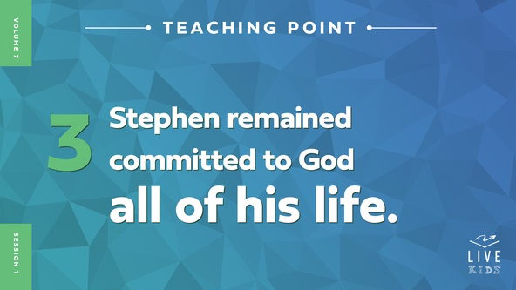

• *Read* [*Acts 7:51–60*](https://ref.ly/logosref/Bible.Ac7.51-60)*.*

Wow! That was intense, and Stephen was brave. He didn’t stop sharing his faith in Jesus. He kept serving God no matter what happened. He actually told the people what they had been doing wrong. Do you think they liked hearing Stephen’s accusations? *(Group response)* No! They were furious!

Do you think their angry response mattered to Stephen? *(Group response)* No. None of that seemed to matter to Stephen. He wasn’t afraid or willing to apologize when he saw how angry the leaders were with him. Do you think you could be brave like Stephen was? *(Group response)* It was all about his focus. Think of it this way.

• *Show the* ***Teaching Time Slide A*** *(zoomed in photo) while you continue to talk.*



What happens when you zoom in close while you’re taking a picture? *(Allow responses.)* You see the part of the picture that you chose to zoom in on really well and really close.

• *Show the* ***Teaching Time Slide B*** *(zoomed out photo) while you continue to talk.*



That’s sort of like what happened with Stephen. He was super zoomed in on Jesus. Even though he could have focused his eyes on the angry people around him, God let his vision zoom right into heaven. He could see Jesus standing there. As Stephen was being stoned to death, he continued to focus on Jesus. He even asked God to forgive them. Do you know what it means to be stoned to death? *(Allow responses.)* It means that people in the crowd picked up and threw rocks at someone until they died. It wasn’t quick, and it was painful. However, Stephen was brave until the end.

It’s probably hard for us to imagine having to suffer to the point of dying for our faith in God. Most of us live in safe places where we don’t have to be afraid of dying because we follow Jesus. But, in some places, people do risk their life to believe in Jesus and follow Him. Stephen showed us what it looks like to be willing to do anything to serve God. Let’s say our Faith Fact to remember that. **I will serve God no matter what.**

**Prayer and Response**

*Consider playing a worship song softly in the background while kids pray.*

|  |
| --- |
| ***You Will Need***   * ***Large Group Response Page****, one per every four kids* * *Pencils, one per kid* * *Scissors*   ***Getting Ready***   * *Print copies of the* ***Large Group Response Page****, one per four kids.* * *Cut apart the pages into four segments each.* |

Now, we have to answer the big question. Are you willing to serve God no matter what? Are you filled up with the right things like the Holy Spirit so you can stand firm when there are times of hardship? Is your focus on Jesus instead of your circumstances? Let’s take a few minutes to think about our commitment to Him. Tell God how you need His help to continue serving Him.

• *Pass out a segment of the* ***Large Group Response Page*** *and a pencil to each kid. Leaders may need to help younger kids write their answers.*

**Prayer**

*Optional: Have the kids repeat phrases of the prayer after you.*

|  |
| --- |
| *Dear God, please help me to have courage, strength, and focus like Stephen had. Help me to serve You no matter what I face. Amen.* |

**Faith Verse**

It’s time to find out the new Faith Verse we’ll learn next. It tells us what we need to do to stand firm in our faith. Our Faith Verse is found in [Ephesians 6:13](https://ref.ly/logosref/Bible.Eph6.13). Let’s learn the actions together.

[Ephesians 6:13](https://ref.ly/logosref/Bible.Eph6.13) (NLT)

Put on every piece of God’s armor so you will be able to resist the enemy in the time of evil. Then after the battle you will still be standing firm.

• *Play* ***Faith Verse Video****.*



When we put on God’s armor and allow Him to help us, He will give us the courage to face any situation. It’s a lot easier to serve God when we have His armor to protect us. Do you think Stephen had God’s armor? *(Group response)* Absolutely!

**Faith Fact**

Before we go to our small groups, let’s review our Faith Fact again. **I will serve God no matter what.**

• *Show the* ***Faith Fact Slide****.*



Let’s spin around while saying the Faith Fact two more times. **I will serve God no matter what.**Whew!I’m just a little dizzy. What about you? *(Group response)* Remember, when life gets hard, keep your focus on Jesus no matter what like Stephen did.

• *Dismiss kids to Small Group time or to go home if your group time ends here.*

**Small Group**

**30 Minutes**

*This section can be done in conjunction with the large group or on its own if you do small groups with your kids. During Small Group time, the goal is to connect the kids with the Word of God and to each other. All activities are led by the small group leader.*

**Group Connection**

**How Can You Serve?**

|  |
| --- |
| ***You Will Need***   * ***Small Group Group Connection Page****, one per group* * *Plastic cups, one per group* * *Scissors* * *Soft ball, one per group*   ***Getting Ready***   * *Print the* ***Small Group Group Connection Page****, one copy per group.* * *Cut apart the slips and fold them so the kids can’t read the slips.* * *Place a set of slips in the cup.* |

Part of being committed to serving God is being willing to serve the people around us. Stephen did that by being part of the team serving food to those in need. God has placed many people in our life for a reason. We can find different ways to serve them and show others His love.

In this activity, we’ll pass a ball around the group. When you get the ball, you’ll choose a slip of paper. It has the name of someone we should serve on it. Each person will come up with ways to serve that person and show them God’s love. When we run out of ideas, they will pass the ball to the next person who will draw a slip. Let’s share.

• *Give the ball and the cup to one of the kids. Have that kid draw a slip from the cup.*

• *After the kid reads the person on the slip, have the group suggest ways to serve that person.*

• *Then the kid should pass the ball to someone else in the group.*

• *Optional: Allow kids to roll the ball across the group to mix up the order of sharing.*

• *Continue to draw slips until they are gone.*

Those were some great ways to serve others. I hope you’ll take some of those ideas and put them into action this week.

**Bible Lesson Recap**

• *If small group activities are not immediately following large group time, you may want to read the Bible story passage before the discussion.*

|  |
| --- |
| ***You Will Need***   * *Bibles for kids in the group to share*   *No prep needed for this activity.* |

**Bible Story Review: Stephen Is Persecuted for His Faith** [**Acts 6:2–15**](https://ref.ly/logosref/Bible.Ac6.2-15)**;** [**7:51–60**](https://ref.ly/logosref/Bible.Ac7.51-60)

In our Bible story, Stephen gave up his life to serve God. Stephen started out doing other things. Can anyone remember what Stephen was chosen to do at the beginning of our Bible story? *(Allow responses.)* That’s right. Stephen and six other men were chosen to lead the food program. They handed out food to people who needed it. Stephen seemed willing to serve God any way he could. God also used Stephen to perform miracles and signs. That’s awesome!

Because of all the incredible things God was doing through Stephen, he caught the attention of some people who didn’t like what he was teaching. When they tried to prove him wrong in a debate, they couldn’t come close to matching his wisdom. They were so angry with Stephen for his debate with them that they made up a bunch of lies and got him arrested.

Stephen had a choice to make. He could have chosen to hide or give up on his faith, but he didn’t. Instead, he boldly proclaimed the truth even though it meant he might end up losing his life. He died because of his commitment to serving God. He refused to back down or turn away from God regardless of what happened to him. Jesus welcomed Stephen into heaven that day because of his incredible sacrifice.

• *Give each kid a Bible and read the Bible story together.*

**Group Discussion**

*Feel free to use all or just a few questions as a jumping-off place for good discussion. Questions marked with * are designed for more conversation. Adjust the questions based on the age or maturity of your group. Typically, older kids will be able to dive a little deeper than younger ones.*

**Questions**

Why do you think Stephen was chosen to serve food to people in need?

How do you think Stephen’s willingness to serve affected others?

* How would you like to serve God right now or when you’re older?

What was Stephen able to do for God because he was a “man full of God’s grace and power”?

Why did everyone stare at Stephen?

* Have you ever seen anyone that you thought looked different because they loved God so much? If so, how would you describe them?

Why did the people come against Stephen?

* How do you think Stephen had the strength to stand firm in his faith even when he knew he might die?

What did Stephen say that helped others know that he was committed to serving God no matter what?

* Is there anything you need to change or let go of to be fully committed to serving God no matter what?

* What can you do to show others that you are committed to God?

**Live It**

**Faith Fact**

Our Faith Fact today is **I will serve God no matter what.** Stephen could do this because serving God was more important to him than life itself. We can, too. Let’s say the Faith Fact together one more time. **I will serve God no matter what.** *(Group response)*

**Challenge**

I want everyone to choose at least one way to show others that you are committed to serving God this week. What will you choose? *(Allow responses.)* Let’s get out there and do it! I can’t wait to hear how God uses you to serve Him when you come back next time.

**Prayer**

*Finish group discussion by sharing prayer requests and praise reports. Keep track of your small group’s prayer requests and review them each time you meet.*

• *Have kids share and pray for each other’s prayer requests.*

|  |
| --- |
| *Dear God, we want to serve You. Help us to remain committed to serving You no matter what. Let everything we say and do help others see You in our life. Amen.* |

**Faith Verse Review**

|  |
| --- |
| ***You Will Need***   * *Bible, one per group*   *No prep needed for this activity.* |

Let’s begin learning our powerful Faith Verse together. Our Faith Verse is [Ephesians 6:13](https://ref.ly/logosref/Bible.Eph6.13). It teaches us how to stand firm in our faith in the face of any difficulty we have.

• *Show* ***Faith Verse Video****.*



[Ephesians 6:13](https://ref.ly/logosref/Bible.Eph6.13) (NLT)

Put on every piece of God’s armor so you will be able to resist the enemy in the time of evil. Then after the battle you will still be standing firm.

Let’s say it together a couple more times. You will definitely want to put this verse in your memory. It will help remind you to stand firm in your faith when you face hard times.

• *Say the verse as a group a couple of times.*

**Faith Verse Fun**

**Pass the “Sword”**

Just a few verses later in [Ephesians 6:17](https://ref.ly/logosref/Bible.Eph6.17), the Bible tells us that God’s Word is a sword. It’s a part of the armor of God we should be using daily. *(Hold up the Bible.)* We’ll pass this sword around and try to remember the Faith Verse one word at a time. Let’s say the verse together.

• *Help kids say the verse word by word.*

I’m impressed that we’re memorizing this Faith Verse. More importantly, we need to make sure we are putting this verse into practice every day.

**Activity Page**

**Serve It Up**

|  |
| --- |
| ***You Will Need***   * ***Small Group Activity Page****, one per kid* * *Pencils, one per kid*   ***Getting Ready***   * *Print copies of the* ***Small Group Activity Page****, one per kid.* |

There are so many ways we can serve others. Let’s focus in on what we can do for God.

• *Hand out a copy of the* ***Small Group Activity Page*** *and a pencil to each kid.*

Let’s look at the first three pictures on the page. Finish the statements and fill in how you can serve others.

• *Help kids finish the statements if needed.*

The last picture is a little different. God used Stephen in special ways. Have you ever thought about how the Holy Spirit might use you like that? For example, maybe you can pray for someone who’s sick, and they are healed. Maybe you boldly proclaim God’s love to people even if they get mad at you and tell you to be quiet. Maybe others can see how much you love God because your face is bright like an angel’s. How would you like God to use you in a special way like that?

• *Ask kids to share what they wrote if they’re willing.*

The Holy Spirit uses people like you and me to show God’s love to others in special ways. I pray that each one of us will serve God no matter what, including allowing the Holy Spirit to use us for God.

**Dismissal**

Stephen was an incredible example of the sacrifice we’re called to make to serve God. We may not all have to give up our life because we serve God, but we must be willing to do whatever it takes. If we keep our focus on Jesus instead of what’s in front of us, He will give us the strength to do what it takes. Let’s pray.

**Prayer**

|  |
| --- |
| *Dear God, thanks for showing us how we can serve You. Help us to go out and live our faith out loud this week. Amen.* |

**Faith Fact Recap**

• *Show the* ***Faith Fact Slide****.*



There is so much more we can learn to help us stand firm in our faith. Come back next time! Don’t miss out on what God has to teach you about standing firm in your faith. Remember today’s Faith Fact as you go out into your week. **I will serve God no matter what.** I can’t wait to see you next time!

• *Send home the* ***Small Group Activity Page*** *and* ***Response Page*** *segment****.***

• *Remind parents that there are* ***Family Devotions*** *available on the app to do with their kid.*

• *Tell everyone the date and time for the next session.*